Learning Journal Unit 2

Godfrey Ouma
University of the People
CS 1101: Programming Fundamentals
Janice Block
June 29, 2023

Part 1: Calculating Circumference of a Circle
"""Input"""
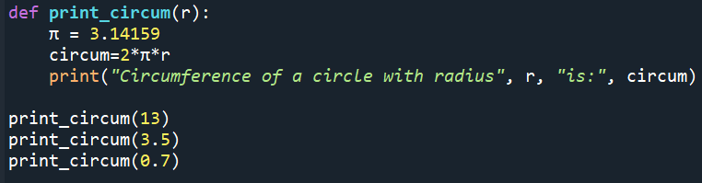
"""Output"""
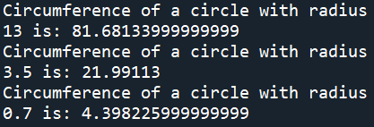

Part 2: Creating a Company Catalogue
"""Input"""
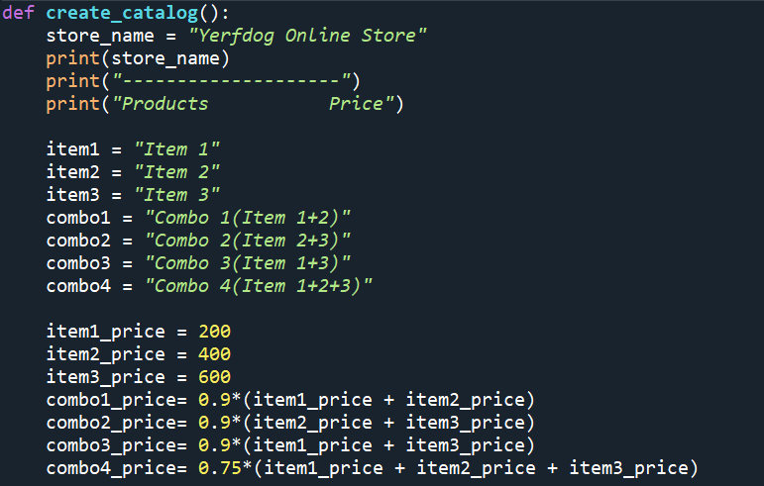
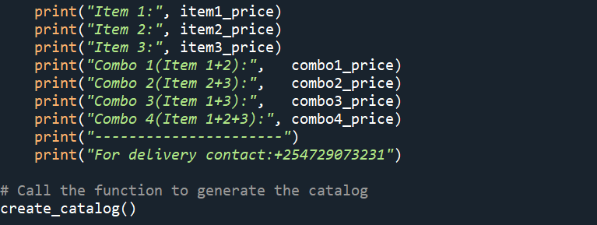
Explanation
The following characteristics are demonstrated by the function create_catalog():
Creating a catalog: The function creates a catalog that includes the name of the business “Yerfdog Online Store” and the heading "Products" and "Prices." According to Downey (2015), a function definition outlines the name of a new function as well as the series of commands that are executed when the function is called. Function “create_catalog()” doesn't take any parameters, as indicated by the empty parentheses after the name (Downey, 2015). Furthermore, the program's quote marks indicate the start and end of the text that will be displayed; they are absent from the final product (Downey, 2015).
Price for each time: Three distinct items—Item 1, Item 2, and Item 3—are each given a price by the function. The names of each item and their matching prices are then printed.
Pricing for combo packs: The function calculates and assigns prices for different combo packs: Combo 1 (Item 1 + Item 2), Combo 2 (Item 2 + Item 3), Combo 3 (Item 1 + Item 3), and Combo 4 (Item 1 + Item 2 + Item 3). It applies discount percentages of 10% for combo packs with two items and 25% for the gift pack (Combo 4).
Prices are displayed: The function uses formatted strings to print the names of the combo packs along with their computed prices.
Contact details: The final step of the program prints a line with a phone number for contacting the retailer about delivery.
The store name, item names, and combo pack names are defined as variables at the beginning of the code. Each product and combo bundle has a corresponding price. Arithmetic operations are used to calculate the combo pack pricing, which are then recorded in variables with the suffix "_price." A variable name may contain the underscore character, “_”, which is frequently used in names that contain several words (Downey, 2015). The function displays the title of the "Products" and "Price" section, a line of dashes, and the store name using print statements. Following that, formatted strings are used to display the costs for both the individual goods and combo packs. The delivery contact information is then printed behind a line of dashes.
"""Output"""
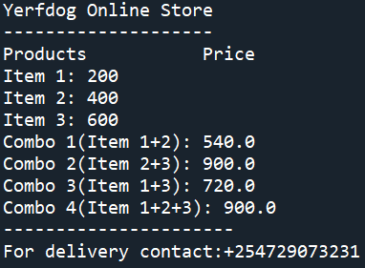
Explanation
The result shows the name of the retailer, the heading of the relevant section, and the pricing for both individual items and combo packs that were determined by the code. The contact information for delivery is provided at the end.

Reference
Downey, A. (2015). Think Python: How to think like a computer scientist. Green Tree Press.

